Architecture Overview

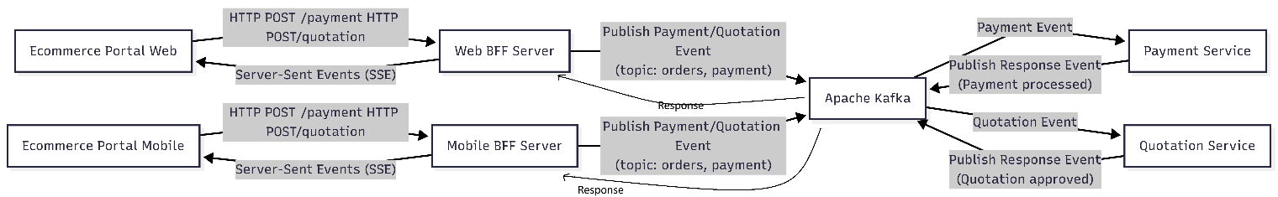

- Ecommerce platform (customer portal and agent portal)
A simple HTML/JavaScript page that allows the following:
Customer to:
1. Browse product
2. Request quotation
3. Review quotation
4. Confirm & pay

Agent to:
  - Create quotation for customer
  - Adjust price / apply discount
  - Approve quotation
  - Trigger payment OR record offline payment

- Mobile and Web BFF (Backend for Frontend)
A Node.js Express server that:
  - Exposes a POST /payment endpoint and quotation endpoint
  - Publishes payments events to Kafka on the payment topic.
  - Publishes quotations events to Kafka on the quotation topic.
  - Listens for response events on the topics and pushes updates to the frontend via SSE.
Each response to the relevant portal

- Microservices
Two separate Node.js services:
  - Payment Service: Processes the order for payment and publishes a "Payment successful" event.
  - Quotation Service: Processes the order for shipping and publishes a "Quotation approved" event.

- Apache Kafka
Serves as the messaging backbone to decouple the BFF and microservices using asynchronous event communication. Ensure idempotency.

Best practices
Security strategy
  - Use TLS
  - Secure API Gateway (Rate limiting)
  - Tokenization (Store only payment token)
  - PII Compliance
    - Store what is needed only
    - Use data only for payment and quotation only
    - Auto delete after x number of days
Observability strategy
Implement app monitoring to monitor:
- Request rate
- Latency (Distributed Tracing)
- Error rate
- Logging

Proactive Monitoring & Alerting

Authentication Strategy
Use Azure Active Directory/Microsoft Entra ID

Authorization Strategy
Rules can be:

| API | Allowed Roles |
| ----------------- | --------------- |
| Create quotation | Customer, Agent |
| Apply discount | Agent |
| Approve quotation | Agent |
| Make payment | Customer, Agent |
| Manual payment | Agent |

Policy-Based Authorization
Rules can be:
Quotation Approval
Allow if:
- role = Agent
- amount ≤ approval limit
- region matches

